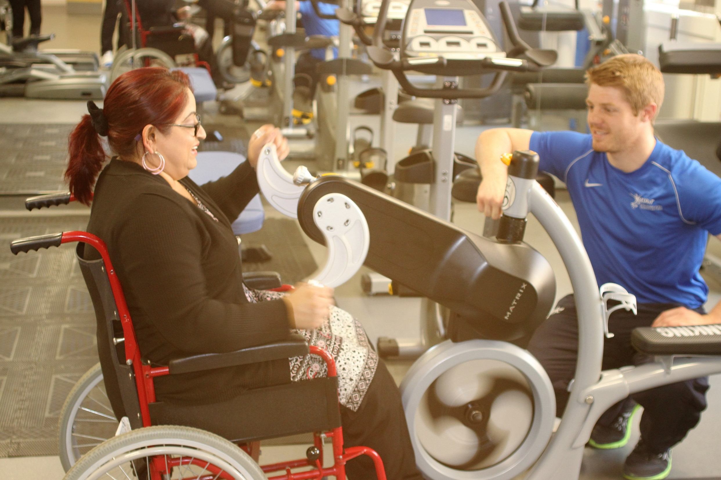

Raising a Concern
Submission form for raising a concern about a BASRaT Registrant.

British Association of Sport Rehabilitators

August 2022

Raising a Concern
Please use this document to raise a concern regarding a registrant of BASRaT. A registrant includes the following membership categories:
- Graduate
- Allied Health Professional
Please note that AHP Registrants of BASRaT will also be on a statutory register (e.g., Health and Care Professions Council) and your concerns should be raised with the statutory register in the first instance.

Before completing this document, you may want to check the type of membership held by the individual concerned (Register Check) - http://www.basrat.org/membercheck

You may also wish to check BASRaT’s definitions of fitness to practise via https://basrat.org/member/fitnesstopractise

The aim of this document is to provide BASRaT with:
- Basic information about yourself and the person you wish to raise a concern about
- Details of the concern
- Desirable outcomes

Your Contact Details

Full Name
Address
Postcode:
Phone Number
Email
Signature
Date

*By signing this form, you are giving BASRaT permission to disclose your details in any investigation relating to this concern.

Registrant Details

Full Name
Registration Number
Contact Information (if known): | Phone:
 | Email:

Details of your concern
Please describe your concern in as much detail as possible, please consider the following:
- Events that took place and if possible, when/where (if applicable).
- Context.
- If an employer, any action taken by yourself/company

You may find BASRaT’s Raising a Concern /FtP Guide useful in filling out this form

Please continue on additional pages if required.

We may contact you to request additional information if required.

Next Steps
Once completed this form can be posted to:

FAO: Registrar
BASRaT Administration Office
PO Box 627
Manchester
M14 0PN

Alternatively, you can also email the form to the BASRaT registrar, registrar@basrat.org or administration office, administration@basrat.org

As another option you can also raise a concern by telephone. In this case, please contact the BASRaT administration office on 0161 295 0070. With your consent, details will be noted using this form and then you may be contacted by the BASRaT Registrar as a follow up.

Please contact BASRaT if you require any support to put your concern in writing. BASRaT will not ignore a concern because it is not in writing and will support those who may be unable to put a concern in writing (e.g., due to language or literacy difficulties).

Administration Office Tel- 0330 133 2123
Administration Email- administration@basrat.org
Registrar Email- registrar@basrat.org

