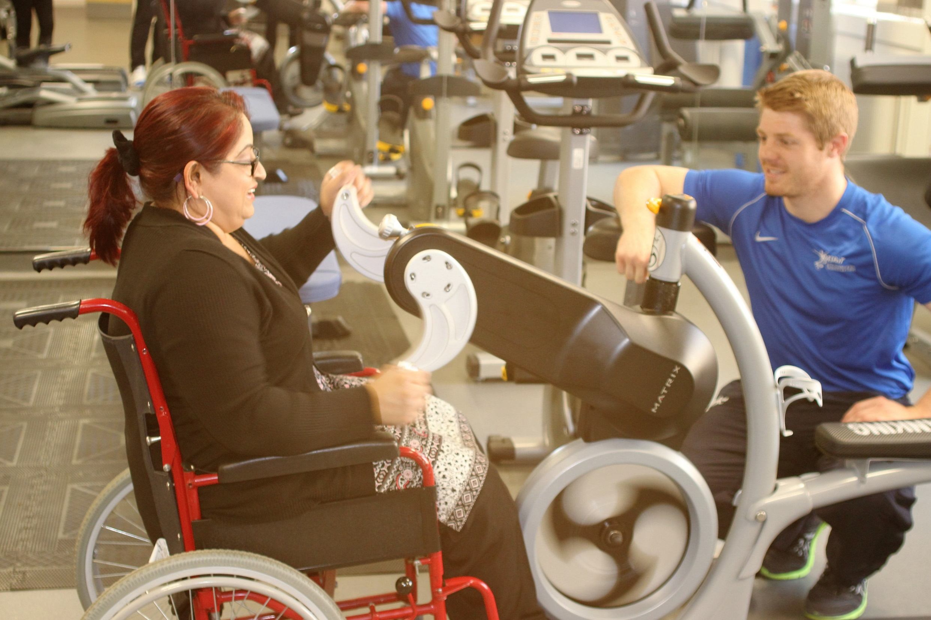

Declaration by Accredited Institution

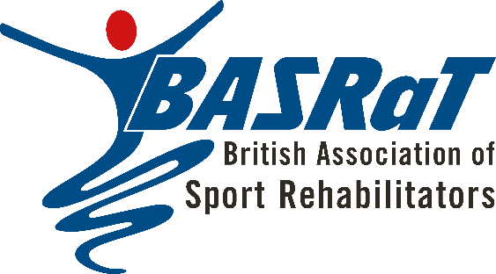
British Association of Sport Rehabilitators

October 2022

Declaration by Accredited Institution
To be completed by the programme lead or head of department.

For guidance on completing this declaration, please refer to the BASRaT Fitness to Practise policy for Accredited Institutions.

Declaration of Fitness to Practise
By signing this declaration, you are declaring that following students from:

Institution:
Of the cohort graduating in the year:

Have successfully completed all elements of the BASRaT accredited programme and is deemed of sufficient health and character to be capable of safe and effective practice without supervision, because:

- No concerns have been raised/investigated regarding their fitness to practise
Or
- They have been investigated under the institutional professional misconduct and/or fitness to practise procedures and no further action or intervention was required.

List of students deemed fit to practise without supervision:

Students from the cohort not included in this declaration and/or not fit to practise without supervision:

Full name:
Signature:
Job Title:
Institution:
Date:

Once completed this document should be returned by email to administration@basrat.org

